Task is associated with/corresponds to the no. of partitions. (1 partition = 1 task)
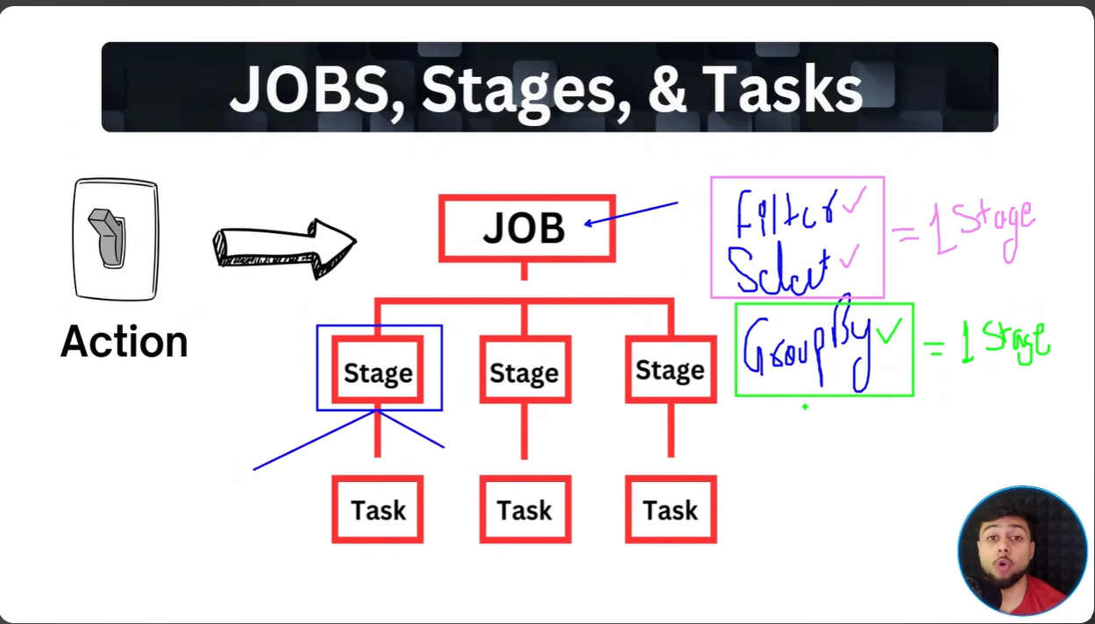
Narrow transformation in 1st stage and wide transformation in another stage.
https://dbc-e409b028-0a41.cloud.databricks.com/editor/notebooks/97372252888692?o=7474645623127556#command/7641009716355600

Whenever we read files to create dataframe, the spark consider it as actions to trigger jobs.
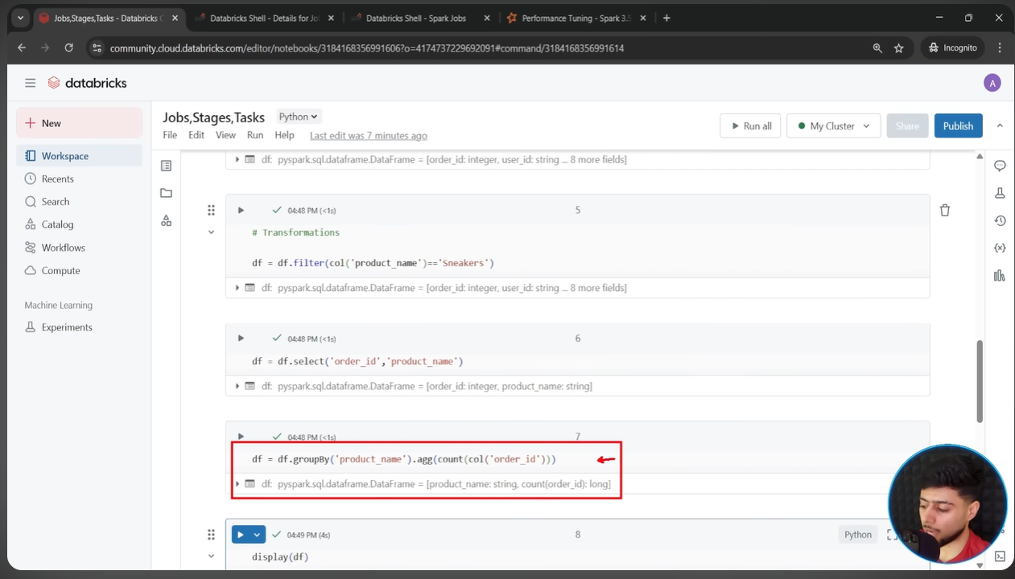

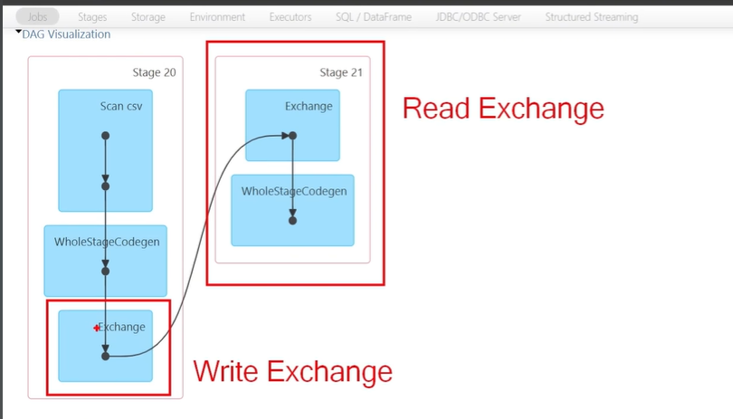
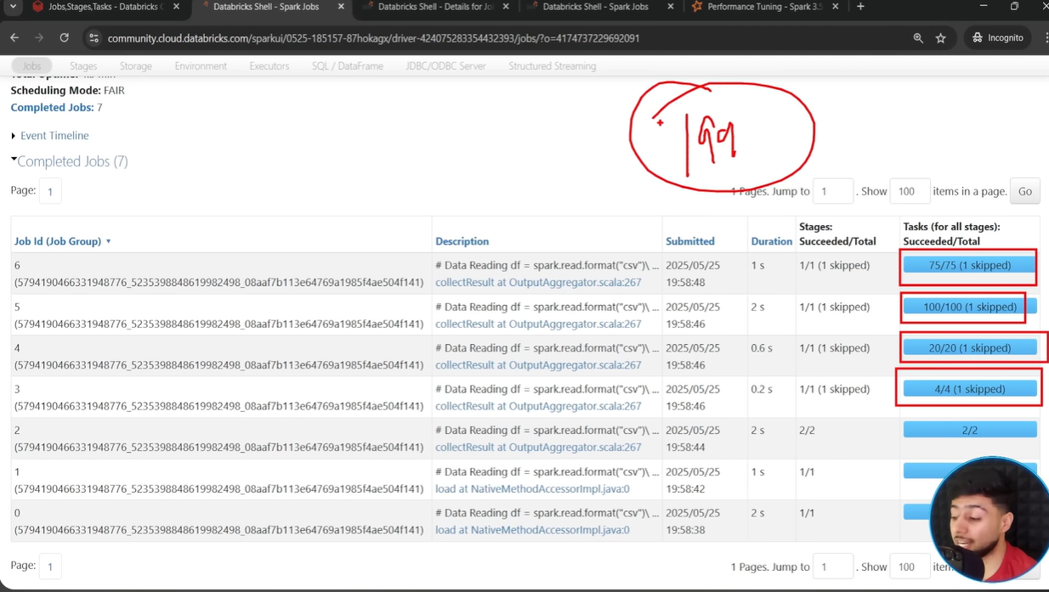
But by default , wide transformation creates 200 partitions and since there is only 1 partition/task required , the other 199 simply skipped.

